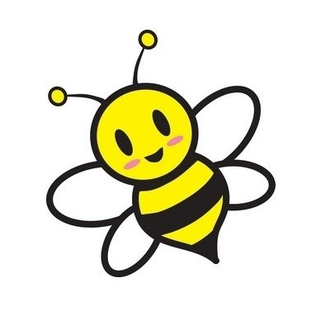

2 rolls of paper towels (select a size)

8 refill packs of unscented baby wipes

One complete change of clothes, labeled in a Ziploc bag

2 containers of playdoh (child’s favorite color, if possible)

2 containers of disinfecting wipes

8 count large round or antiroll crayons (triangular shape)

1 **FULL SIZE** backpack - (large enough for a 9x12 folder and the lunch box)

Lunch box - please label the lunch box and any plastic storage containers inside

*send a clean sippy cup of water each day for snack*

*and 3 diapers in his/her backpack*

Girls - 1 bottle (12 oz. or larger) hand sanitizer

Girls – 1 – box Ziploc gallon bags

Boys – 1 can of Lysol spray

Boys – 1 box Ziploc quart bags

**Busy Bee**

**Supply List**