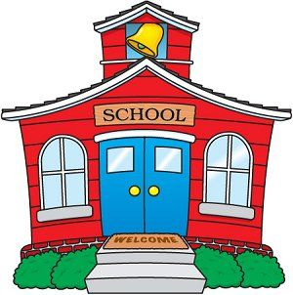

**Kindergarten**

**Supply List**

1 regular size backpack (big enough to hold folders and books)

Change of clothing (labeled in Ziploc bag)

1 – 1 inch white binder with clear front

1 school supply box (plastic with attached lid)

1 pair of Fiskar scissors

2 boxes of 24 Crayola crayons

2 boxes of washable Crayola markers (classic colors)

Glue sticks (8 or 10)

1 bottle of Elmer’s glue

Plain white paper plates

1 Clorox wipes

1 package multi colored cardstock

1 package baby wipes

1 large bottle of hand sanitizer

Girls – 1 box of quart size Ziploc bags

Girls – 1 package of napkins (for snack)

Boys – 1 box of gallon size Ziploc bags

Boys – 1 roll of paper towels