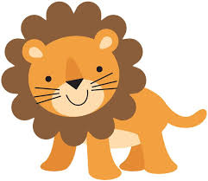

**Lions**

**Supply List**

1 regular size backpack with zipper closure

(big enough to hold a folder)

1 full change of clothes in a labeled Ziploc bag

1 pair of Fiskar scissors

2 boxes of washable Crayola markers (classic colors)

1 box of Crayola crayons (24 count)

2 sets of 8-count watercolor paints – Crayola

1 one-inch **white** 3-ring binder (please purchase one with a clear pocket on the front)

2 containers of Clorox wipes

12 glue sticks (school glue sticks work best)

2 rolls of paper towels

1 pencil box (large enough to hold supplies)

3 packages of wet wipes (baby wipes)

Hand sanitizer

6 pack playdough

Boys – sandwich size Ziploc bags

Girls – snack size Ziploc bags

Boys – white cardstock

Girls – colored cardstock