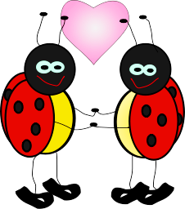

**Love Bug**

**Supply List**

1 regular size backpack with zipper closure (big enough to hold a folder and lunchbox)

1 pencil box (plastic with attached lid)

1 pair of Fiskar scissors

2 boxes of 24 Crayola crayons

1 one-inch, white three ring binder (please purchase one with a clear pocket on the front)

4 glue sticks (school glue sticks work best)

4 pack Playdough

2 rolls paper towels

Boys – 2 packs of white cardstock

Girls – 2 packs of colored cardstock

1 full change of clothes labeled in a Ziploc bag