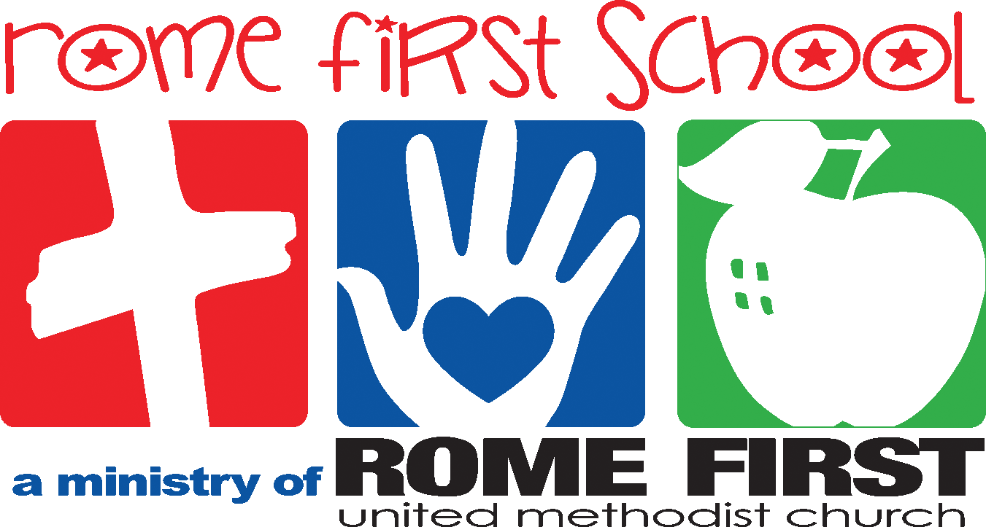

School Calendar 2022-2023

Meet the Teacher Aug. 11
First Day of School August 15
Labor Day – No School September 5
Fall Break October 10-13
Costume Parade TBD
Thanksgiving Program November 17 (tentative)
Thanksgiving Holidays November 21-24
Christmas Holidays December 16-January 3
Classes Resume January 4
MLK Holiday – No School January 16
Registration opens for current families February 1
Registration opens for new families February 15
President’s Day – No School February 20
Spring Break April 3-6
End of the Year Program TBD
Last Day of School Wednesday, May 17

*We follow the Rome City School System for inclement weather closings. Listen to local radio stations for school closing announcements

