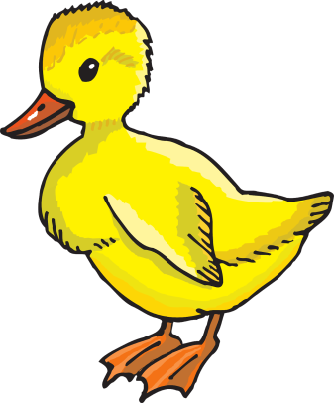

**Duckling**

**Supply List**

4 refill packages **unscented** Baby Wipes

2 Containers of Clorox wipes

2 Rolls paper towels

1 container of Play-doh

1 can Lysol

1 hand sanitizer (small)

One complete change of clothes, labeled in a Ziploc bag

Boys – 1 box of Kleenex

Girls – 1 bottle Foaming hand soap

*sippy cup daily for water*