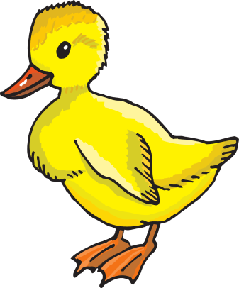

**Duckling**

**Supply List**

8 refill packages **unscented** Baby Wipes

3 Containers of Clorox wipes

3 Rolls paper towels

One complete change of clothes, labeled in a Ziploc bag

Boys – 1 box of Kleenex

Girls – 1 bottle Foaming hand soap

*sippy cup daily for water*