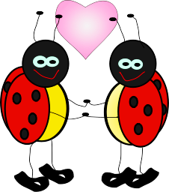

**Love Bug**

**Supply List**

1 regular size backpack with zipper closure (big enough to hold a folder and lunchbox)

1 school supply box (plastic with attached lid)

1 pair of Fiskar scissors

2 boxes of 24 Crayola crayons

2 boxes of WASHABLE Crayola markers (classic colors only) (other brands do not last as long)

1 set of 8 count watercolor paints

1 one-inch, white three ring binder (please purchase one with a clear pocket on the front)

6 glue sticks (school glue sticks work best)

2 bottles of Elmer’s glue

2 refill packs of baby wipes

1 roll paper towels

1 Clorox wipes

Girls – 1 pack of pencils

Boys – 1 sandwich size Ziploc bags

1 full change of clothes labeled in a Ziploc bag

*Wish list: -white cardstock

-gallon Ziploc bags