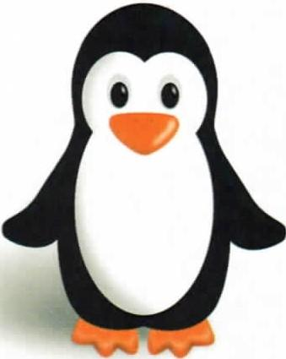

**Penguin**

**Supply List**

1 pkg 8 count fat crayons

1 pkg markers

1 plastic pencil box – small

1 pkg of paper plates

1 roll of paper towels (select a size)

6 pkgs of baby wipes

2 containers of Clorox wipes

1 can of Lysol spray

1 full size backpack

One complete change of clothes, labeled in a Ziploc bag

Clean sippy cup of water each day