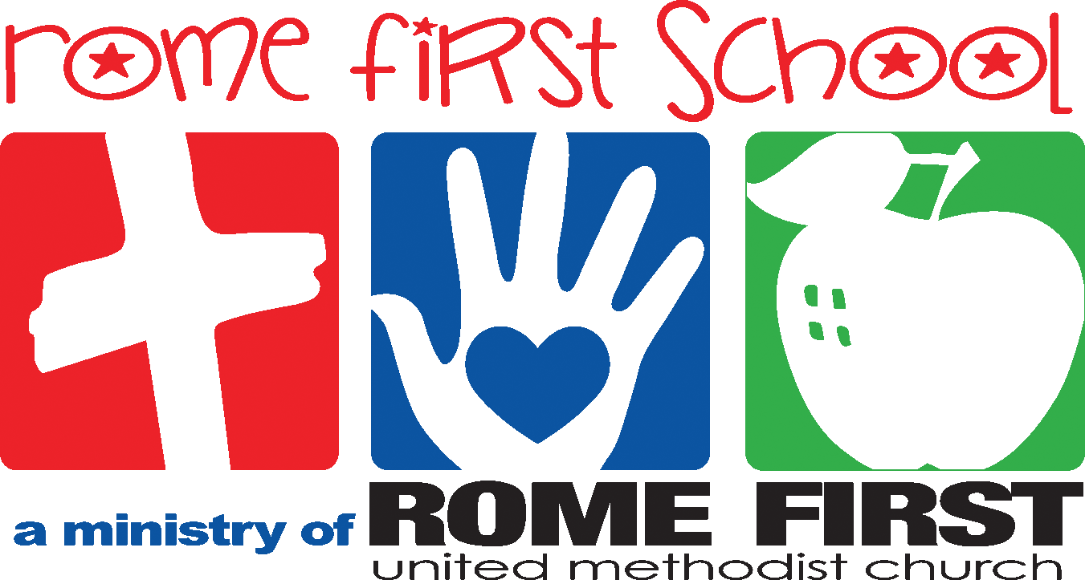
School Calendar 2018-2019

Pre-Planning August 13-16
Orientation August 16 @ 10:00 AM
First Day of School August 20
Labor Day – No School September 3
Fall Break October 1-4
Thanksgiving Program November 15 @ 5:30 PM
Thanksgiving Holidays November 19-22
Christmas Holidays December 21-January 6
Resume Classes January 7
MLK Holiday – No School January 21
Registration opens for current families February 6
President’s Day – No School February 18
Registration opens for new families February 20
Spring Holidays March 25-28
End of the Year Program May 21 @ 11:00 AM
Last Day of School May 21
Post Planning May 22 – 23
*We follow the Rome City School System for inclement weather closings. Listen to local radio stations for school closing announcements

