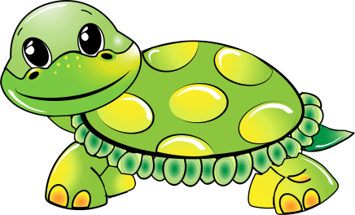

1 box of Kleenex

1 Crayola watercolor

6 packages of **unscented** baby wipes

2 containers of Clorox wipes

1 roll of paper towels

One complete change of clothes, labeled in a Ziploc bag

1 full size backpack (large enough for a 9x12 folder and lunch box)

Lunch box – please label the lunch box and any plastic storage containers inside

1 package of paper plates (uncoated)

1 pkg 8 count fat crayons

1 pkg coffee filters (for snack)

4 pack Playdough

Girls – 1 bottle of hand sanitizer

Girls - 1 box of Ziploc gallon bags

Boys – 1 can of Lysol spray

Boys – 1 box of Ziploc sandwich bags

*clean sippy cup of water each day for snack*

*3 diapers in his/her backpack each day*

**Turtle**

**Supply List**