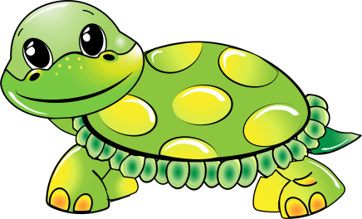

**Turtle**

**Supply List**

6 packages of **unscented** baby wipes

2 containers of Clorox wipes

2 cans of Lysol

One complete change of clothes, labeled in a Ziploc bag

1 full size backpack

1 package of paper plates

1 box of Kleenex

1 roll of paper towels (select a size)

1 pkg coffee filters

6 glue sticks

2 bottles glue

*clean sippy cup of water each day for snack*